**CLASS DIAGRAM**

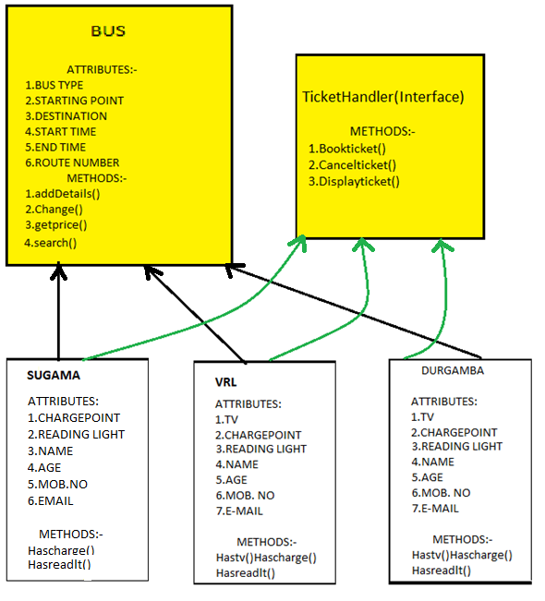

**CLASS Bus**

Description:

A)Variables:

* An abstract class containing the basic attributes of a bus such as the type of bus(AC/NON AC etc) ,the starting point, destination, start and end time and route number.
* Besides the above it also has a two dimensional variable seat matrix to store the same as well as the price of a ticket ,discount offered(if any) as well as the cancellation fee.

B).Methods:

* The method addDetails() is used by the programmer to add the list of buses and details initially.
* Change() on the other hand is used by the administrator to change the details of a particular bus, add a new bus, change or cancel bus routes etc.
* The method getprice() performs the task of data encapsulation by providing access to private variable 'price'.
* search() is used by both the user and admin to search for a particular bus.

The class Bus is an abstract class and hence cannot be instantiated. It is inherited by the classes of the different types of buses(Vrl, Durgamba etc) which perform polymorphism by overriding its methods and performing their own implementation.

**INTERFACE Tickethandler:**

Description:

* Has methods Bookticket() and Cancelticket().
* Bookticket() is used by the user to book his ticket and takes his personal details while booking the tickets.
* Cancelticket() is called when a user wants to cancel his tickets.
* Displayticket() is called once the ticket details have been confirmed. A soft copy of the ticket will be displayed, consisting of the details of the bus as well as the passenger.

**CLASS Durgamba**

Description:

A).Variables

* Has variables tv,chargept and readlight which are of boolean type to indicate if the Durgamba bus selected has any of the above amenities.
* Has variables name, age, sex, mobno, email to store details of a passenger travelling in the bus.

B)Methods

* Hastv(),Hascharge() and Hasreadlt() returns TRUE if the bus has these amenities and FALSE if it doesn't.

**CLASS VRL**

Description:

A).Variables

* Has variables tv,chargept and readlight which are of boolean type to indicate if the VRL bus selected has any of the above amenities.
* Has variables name,age,sex,mobno,email to store details of a passenger travelling in the bus.

B)Methods

* Hastv(),Hascharge() and Hasreadlt() returns TRUE if the bus has these amenities and FALSE if it doesn't.

**CLASS Sugama**

Description:

A).Variables

* Has variables chargept and readlight which are of boolean type to indicate if the Sugama bus selected has any of the above amenities and thus shows the difference between the various buses as this bus does not have a TV amenity.
* Has variables name,age,sex,mobno,email to store details of a passenger travelling in the bus.

B)Methods

* Hascharge() and Hasreadlt() returns TRUE if the bus has these amenities and FALSE if it doesn't.

**Some Miscellaneous points**

* We create an arraylist of objects of class Durgamba,VRL and Sugama so that dynamic allocation and efficient use of memory takes place.
* The person using our program can be either a user or administrator and he will select this option before he starts using the program(an admin will have to enter a password).
* All the classes are available for access by both user and administrator, the difference being in the functionality offered to each, i.e, an administrator will be offered a different menu and will be allowed to change bus details and so on while a user will not.